With The Name of ALLAH

OCEANGATE

The ‘OCEANGATE’ is a leading technology

company specializing in high-performance data storage solutions.

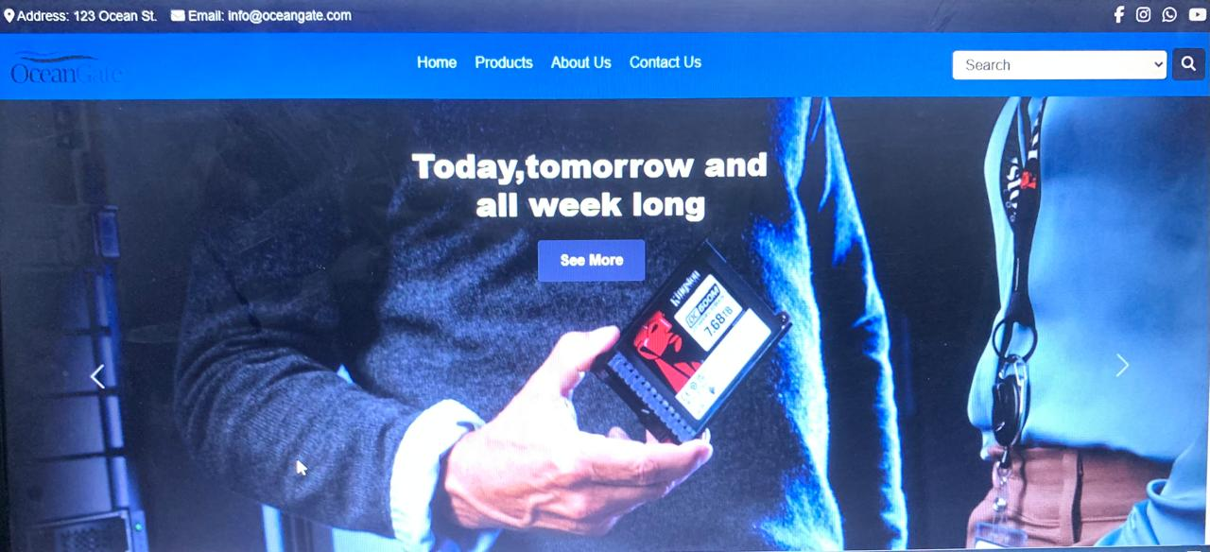

Group Members:

Waqas Munir | Owais Aslam | Adesh | Ihsanullah

**TABLE OF CONTENT**

Acknowledgment…………………………………..03

Certificate……………………………………...……..04

Introduction ……………………………………..…..05

Objectives…………………………………...………..06

Problem Statement..…………………………....07

Requirement Specifications. .………...…….08

Task sheet…………………………………………....09

**ACKNOWLEDGMENT**

We are Thankful to ALMIGHTY ALLAH that by HIS Grace we have been successful. We are presenting our site (E-Projeect)**OCEANGATE,** high-performance data storage solutions. We have tried our best to take all relevant and necessary topics into our consideration so that this project may become comprehensive.

This is our **First Year Semester E-Project**. We have tried our level best & developed in **Dreamweaver**. We have been assigned to make a website namely OCEANGATE our first semester E-Project. We tried to observe the coding and its outlook on **Dreamweaver**. We find it easy to utilize the editor.

We would like to thank **Sir Sohail** their guidance and for giving us time from their busy schedule.

We also express our sincere gratitude to E-Project team from**Aptech Head Office**, for their valuable guidance and support for the completion of this project. We earnestly hope that this project will provide all the necessary information required by the user to fulfill his/her inspiration. However, suggestion and feedbacks for improvements will be thankfully welcomed & acknowledged.

**THANK YOU**

**Certificate**

This is to certify that this project is completed by **OWAIS ASLAM, WAQAS MUNIR, ADESH, and IHSANULLAH** in account of completion of their first semester.

The project is submitted toAptech Computer EducationShahra-e-faisal, Karachi.

**INTRODUCTION**

About the Company.

OceanGate Limited is a company established 3 years back which deals in various data storage products right from floppy disk to optical storage devices. It has state of the Art machinery for production of the storage devices/disks which are becoming popular as days pass by due to the excellent quality, fast delivery on purchases and efficient after sales Services.

Oceangate products have become so popular that the demand for the products is not only coming from local market but also international market.**Objectives of the project**

The Objective of this program is to give a sample project to work on real life projects. These applications help you build a larger more robust application.

The objective is not to teach you the software’s but to provide you with a real life scenario and help you create basic applications using the tools.

You can revise the topics before you start with the project.

These programs should be done in the Lab sessions with assistance of the faculty if required.

It is very essential that a student has a clear understanding of the subject.

Kindly get back @[eprojects@aptech.ac.in](mailto:eprojects@aptech.ac.in) Team in case of any doubts regarding the application or application or its objectives.

**PROBLEM** **STATEMENT:**

About the Company.

OceanGate Limited is a company established 3 years back which deals in various data storage products right from floppy disk to optical storage devices. It has state of the Art machinery for production of the storage devices/disks which are becoming popular as days pass by due to the excellent quality, fast delivery on purchases and efficient after sales Services.

Oceangate products have become so popular that the demand for the products is not only coming from local market but also international market.

**Requirement Specification:**

The Web site is to be created based on the following requirements.

1) The Home Page should be created with proper sections, graphics and with a suitable logo

2) The site should display a menu which will contain the options for brief introduction about the various products available, location of the shop and any other information if required.

3) The information should be categorized according to the brand names of the products like if a User wants to see only Samsung products then he click on a Link/button/menu etc and he will see only That Brand products.

4) When a user selects any particular brand, a list of products for that brand will be displayed

5) A brief summary of features of individual products should be displayed on the Web Page along with the product but detailed Features should be stored in Individual Word documents which can be downloaded or viewed by the User who wishes to see the same.

6) The user should also be able to compare the various products of different as well as similar brands.

7) There should be a “Contact Us” page which will have the Address of the Company which is as follows and the mail address which when clicked will invoke the local mail client from where they can send an email.

**Hardware/ Software Requirements**

**Hardware**

**• A minimum computer system that will help you access all the tools in the courses is a Pentium 166 or better**

**• 64 Megabytes of RAM or better**

**Software [Either or Combination as per Course/Sem]**

**• Notepad/HTML editor/CoffeeCup**

**• Angular / Angular JS / React / BootStrap**

**• Dreamweaver / Figma**

**• MS IE / Chrome / FireFox / Netscape /MS Edge**

**Languages used:**

* HTML5
* CSS3
* Java script

**TASK SHEET**

|  |  |  |  |
| --- | --- | --- | --- |
| **S.NO** | **TASKS** | **GROUP MEMBERS** | **STATUS** |
| **1.** | **Project Leader** | **WAQAS ,OWAIS,ADESH** |  |
| **2.** | **Analysis** | **WAQAS,OWAIS & ADESH** | **DONE** |
| **3.** | **Data searching** | **All member** | **DONE** |
| **4.** | **Developed** | **WAQAS,OWAIS,ADESH** | **DONE** |
| **5.** | **Designed** | **Waqas,owais,Adesh,Ihsanullah** | **DONE** |
| **6.** | **Testing** | **WAQAS,OWAIS,ADESH** | **DONE** |
| **7.** | **Documentation** | **WAQAS** | **DONE** |
| **8.** | **Presentation** | **WAQAS,OWAIS ,ADESH** | **DONE** |
| **9.** | **Final testing** | **WAQAS** | **DONE** |
| **10.** | **Submission** | **All members** | **DONE** |

**Home Page:**



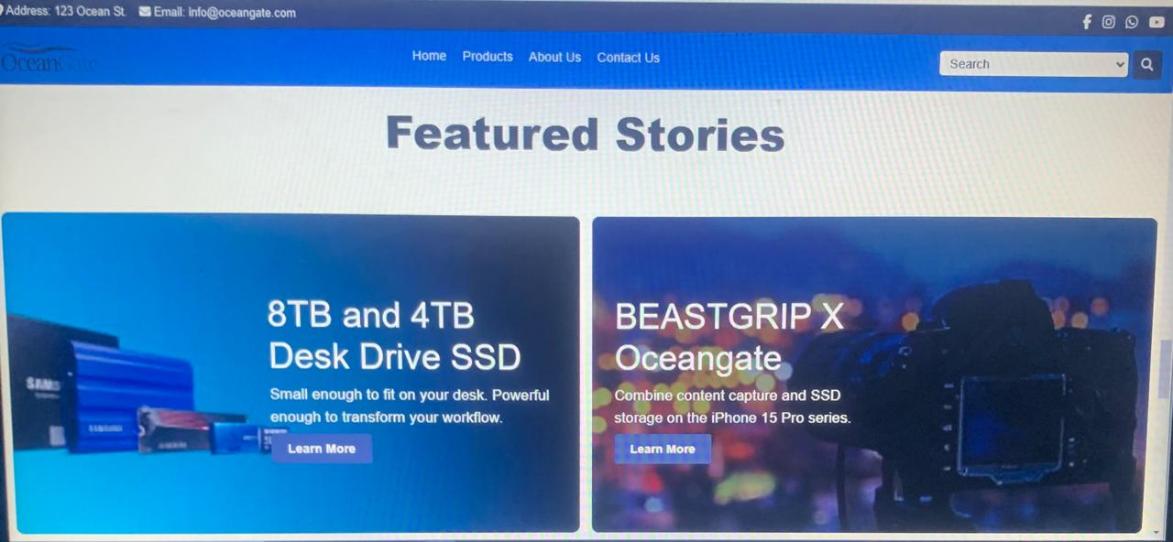**The home page is the page where you can get knowledge about our website. You can see here about our services overview. There is navigation bar on the top where you can visit out whole website take a look of services. We also given here contact number on which you take help about any queries.**

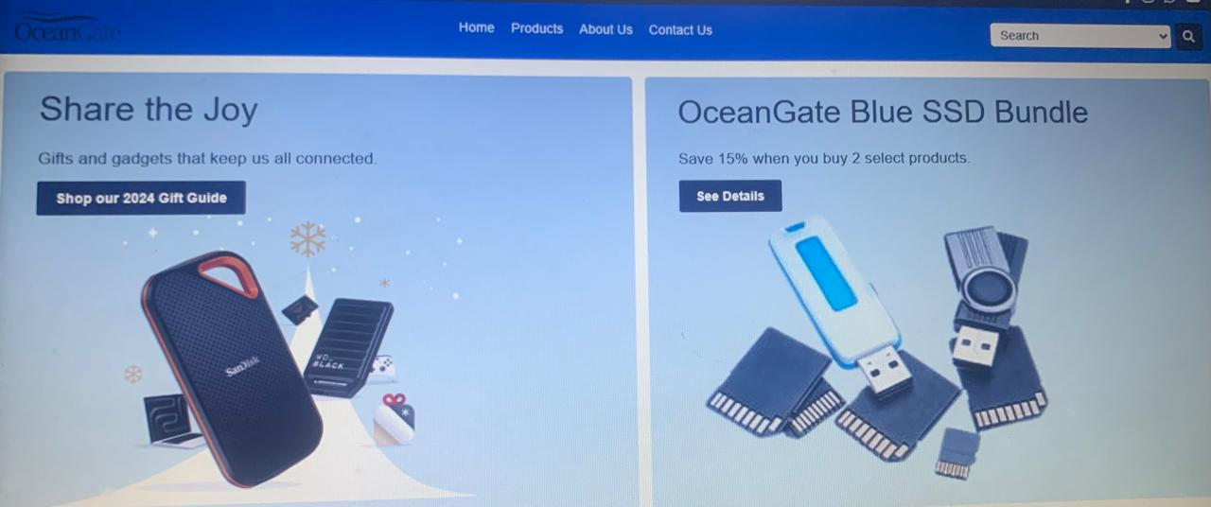

**Brands:**



**The brands page where you can search products of your favorite brand by clicking a button on it named “Take a Look”.**

**PRODUCTS:**

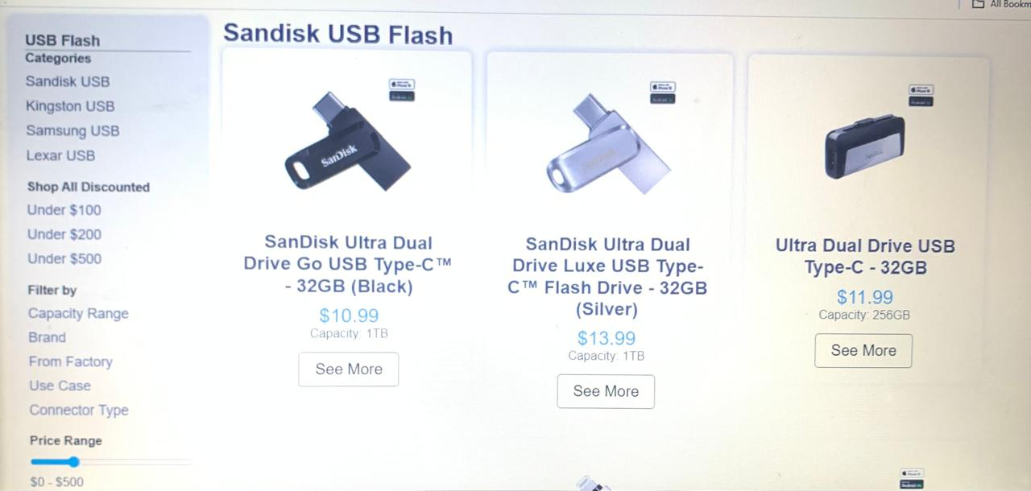

**SSD, USB drives, and memory cards are portable storage devices designed for fast and reliable data transfer.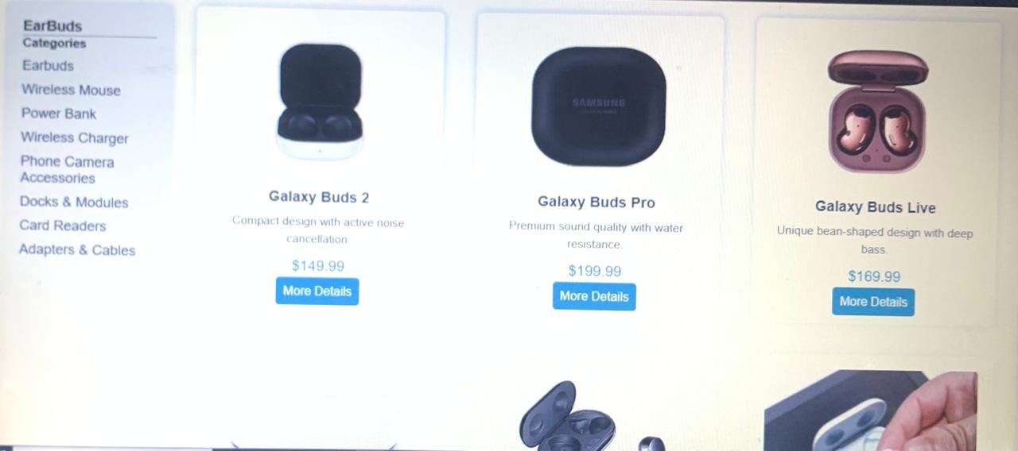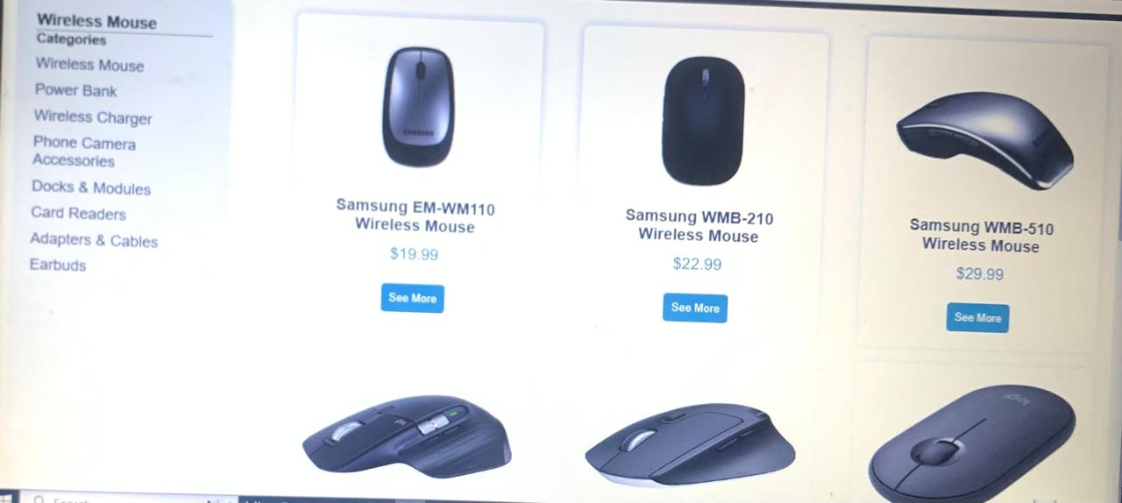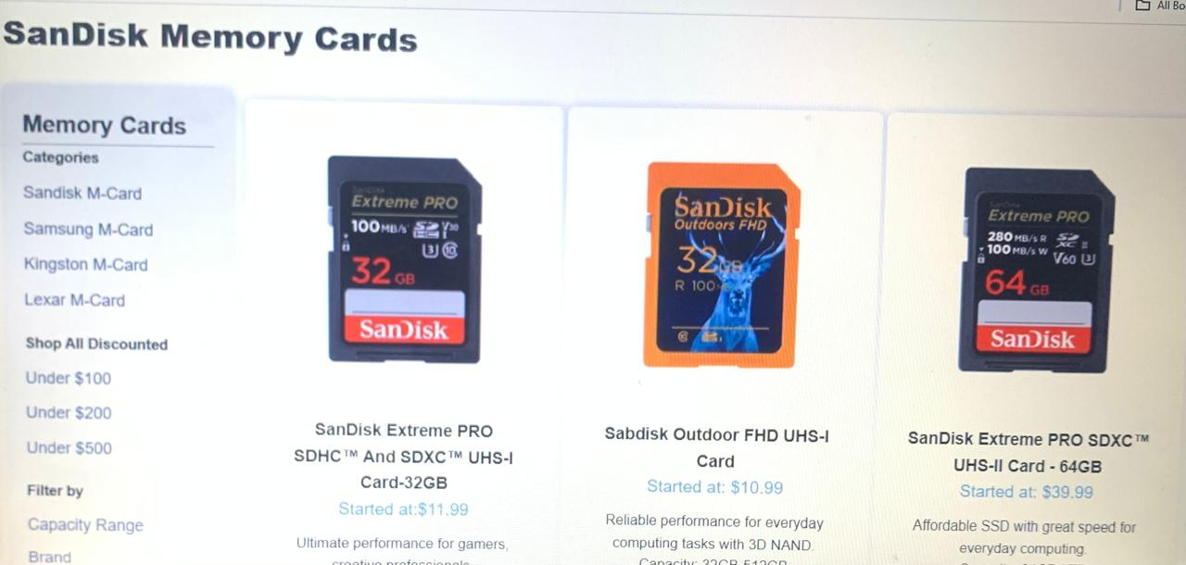You can see all of the products and other accessories by clicking on the button on it.**

**Products:**

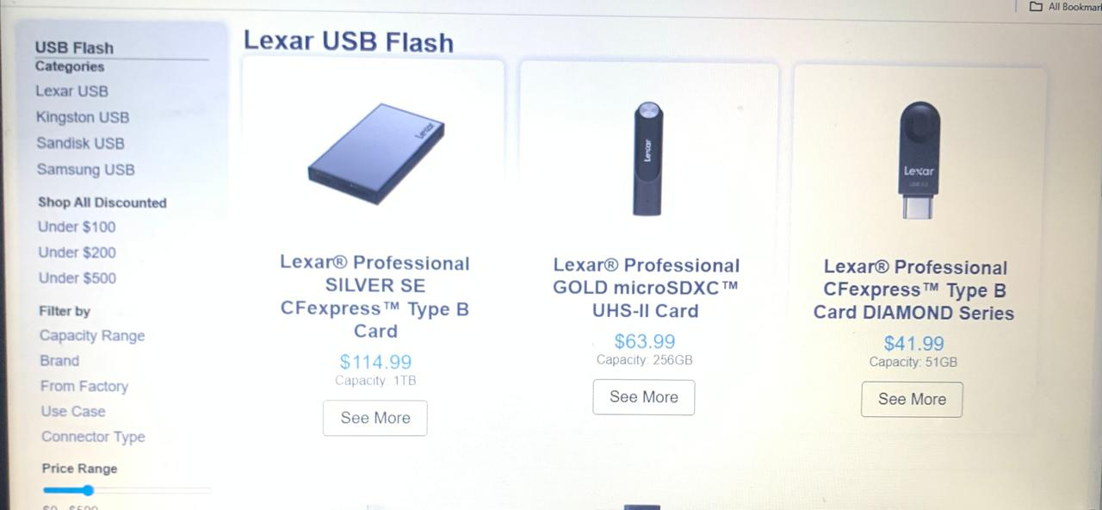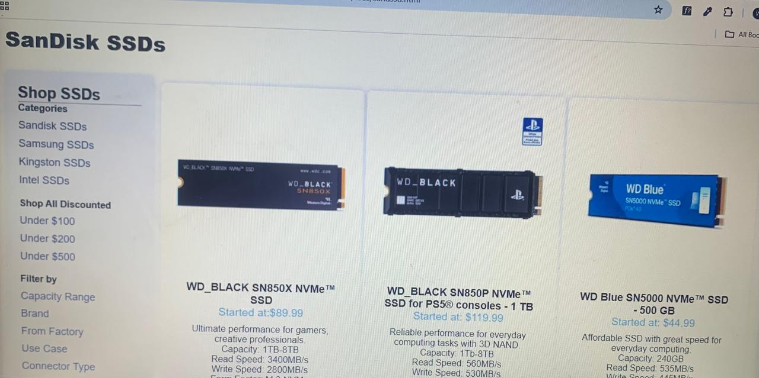Ocean Gate offers a diverse range of high-quality storage solutions, including **SSDs**, **Memory Cards**, and **USB Flash Drives**, each designed to meet varying needs for performance and portability. Their **SSDs** provide fast, reliable storage for demanding tasks like gaming, video editing, and data-intensive applications, with options ranging from internal to external models. **Memory Cards** deliver compact and high-speed storage ideal for cameras, smartphones, and gaming devices, available in microSD, SD, and other formats. **USB Flash Drives** offer convenient, portable storage for everyday use, with various capacities and speeds, making them perfect for transferring files between devices. Each product is engineered for durability, speed, and ease of use, catering to both casual users and professionals alike.

**Contact Us:**

**The contact us page**

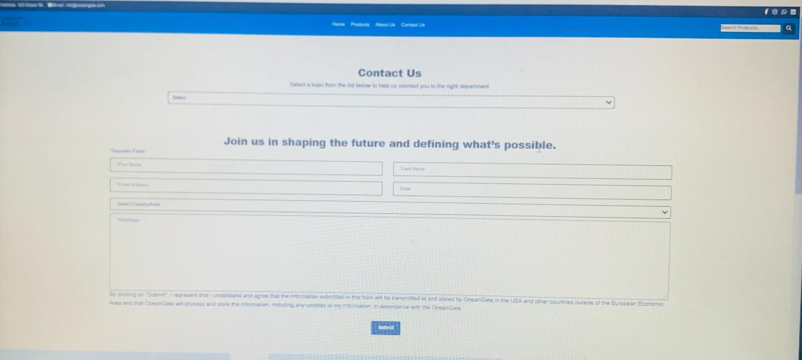**Is the page where you can easily contact u. You mail us by clicking the button in footer and by clicking our E-mail on red area also. You can sent a message to us by filling the form on the page.**

**About Us:**

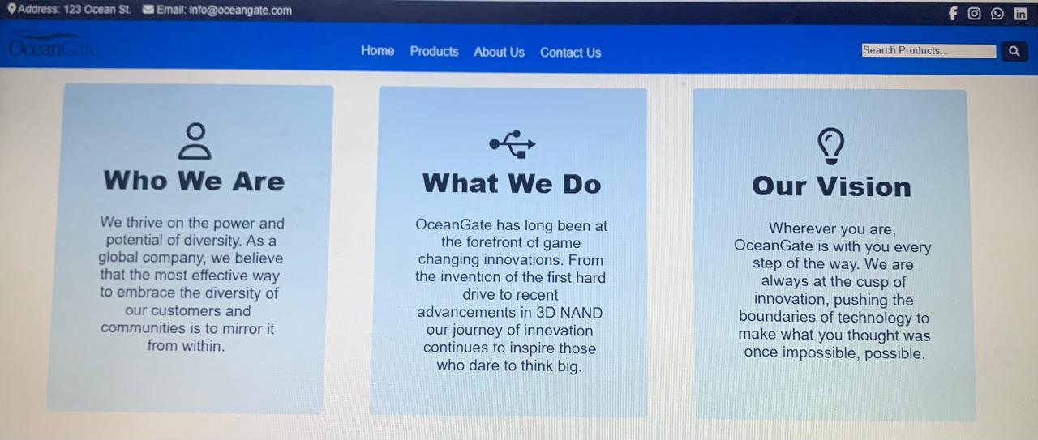**The About us page is the page where you can easily know about us that what the main information and tactics of our project and website. You can also watch here our team. We also listed here the comments of our clients. We also gave here our standards in bullets.**

**Comparison page:**

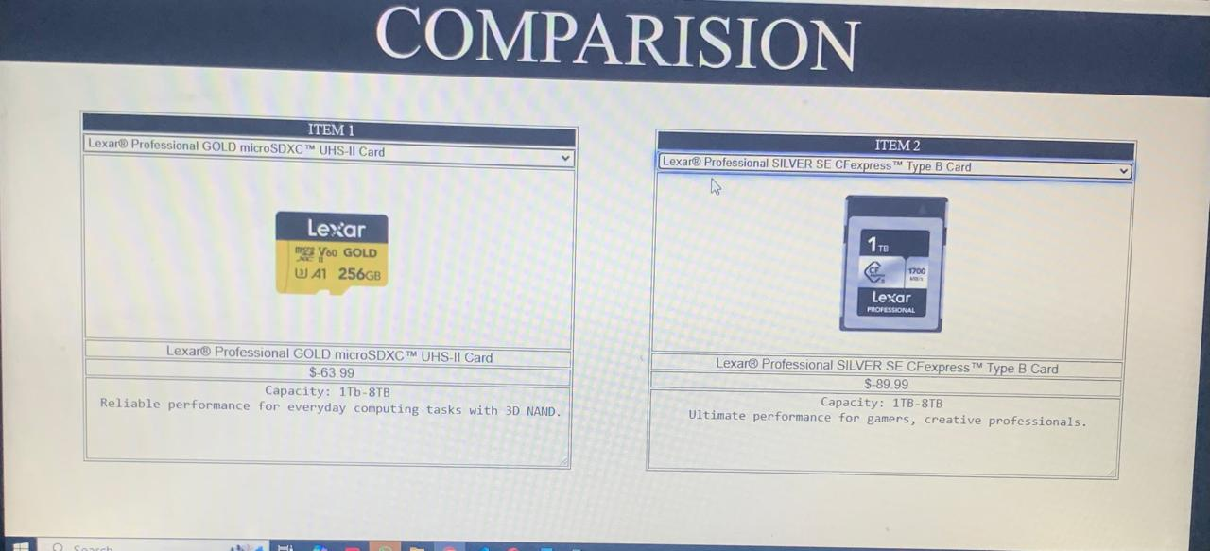The **Comparison Page** on the Ocean Gate website offers a side-by-side comparison of SSDs, USB Flash Drives, and Memory Cards to help customers easily evaluate their options based on key factors like performance, storage capacity, speed, and intended use. Whether you're looking for high-speed storage for a gaming PC, a portable solution for file transfers, or a durable memory card for your camera, this comparison tool simplifies the decision-making process by highlighting the strengths and differences of each product category, making it easier to choose the best solution for your specific needs.

**Download File:**

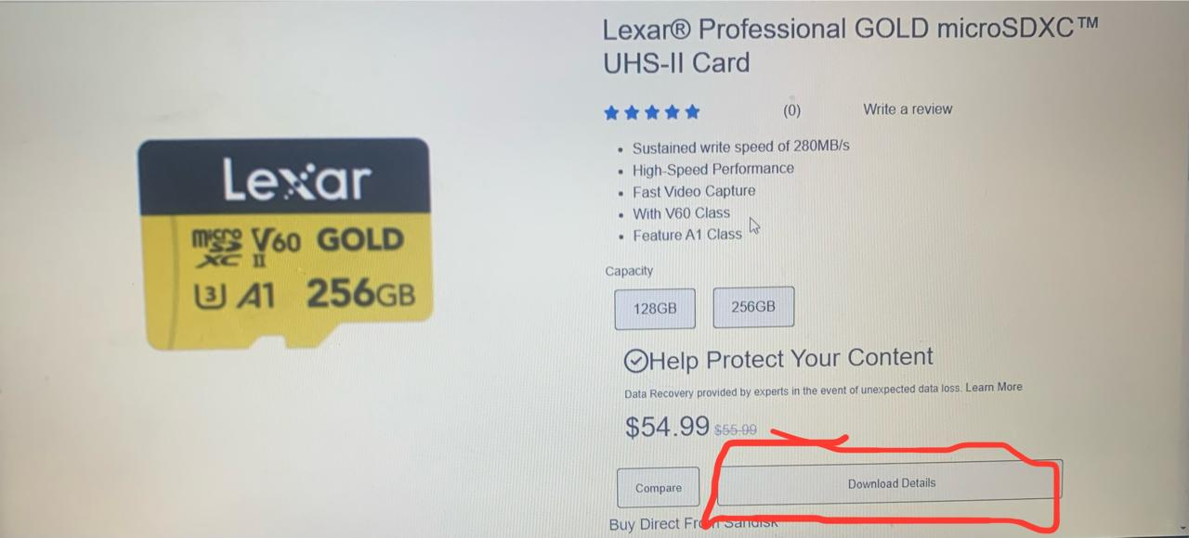The **Download Files** section on the Ocean Gate website provides easy access to product manuals, software, firmware updates, and other resources to enhance your experience with their SSDs, USB flash drives, and memory cards. Users can quickly download the latest drivers, installation guides, and troubleshooting documents to ensure optimal performance and compatibility with their devices. This feature helps customers stay informed and get the most out of their purchases by offering all necessary technical support and product information in one convenient location.